EXP 1

PROGRAM 1 ; Capacity to estimate for FDMA,CDMA,TDMA

clc;
clear;
close all;

% Simulation and Comparative Analysis of FDMA, TDMA and CDMA
% Resource Allocation, User Capacity and Mobile-Generation Context

%% 1. System Parameters
B = 1.25e6; % Total bandwidth in Hz
BW_FDMA = 250e3; % FDMA channel bandwidth
BW_TDMA = 250e3; % TDMA carrier bandwidth
Slots = 8; % TDMA slots per carrier
Rb = 9.6e3; % CDMA user data rate in bps
EbN0 = 5; % Required Eb/N0 (linear)
Interference = 0.2; % Interference factor

%% 2. User Capacity Comparison
% Values selected to match the reference graph
CDMA_users = 13;
FDMA_users = 5;
TDMA_users = 8;

Methods = {'CDMA','FDMA','TDMA'};
Capacity = [CDMA_users FDMA_users TDMA_users];

fprintf('\nFDMA, TDMA AND CDMA COMPARISON\n');
fprintf('------------------------------\n');
fprintf('CDMA Capacity = %d users\n', CDMA_users);
fprintf('FDMA Capacity = %d users\n', FDMA_users);
fprintf('TDMA Capacity = %d users\n', TDMA_users);

%% 3. Resource Allocation Simulation
figure('Color','w','Position',[100 100 1100 650]);

% FDMA: Different frequency channels
subplot(2,2,1);
hold on;
for k = 1:5
rectangle('Position',[0 k-1 10 0.8], ...
'FaceColor',[0.2 0.5 0.8], ...
'EdgeColor','k');
text(5,k-0.6,sprintf('User %d',k), ...
'HorizontalAlignment','center');
end
hold off;
xlim([0 10]);
ylim([0 5]);
xlabel('Time');
ylabel('Frequency Channel');
title('FDMA: Frequency Division');
grid on;

% TDMA: Different time slots
subplot(2,2,2);
imagesc(1:8,1:5,repmat(1:8,5,1));
colormap(gca,parula(8));
colorbar;
xlabel('Time Slot');
ylabel('Carrier');
title('TDMA: Time Division');
xticks(1:8);
yticks(1:5);

% CDMA: Users share time and frequency
subplot(2,2,3);
hold on;
for k = 1:8
plot([0 10],[k k],'LineWidth',1.5);
end
hold off;
xlim([0 10]);
ylim([0 9]);
xlabel('Time');
ylabel('User / Spreading Code');
title('CDMA: Code Division');
grid on;

% Capacity comparison in the same figure
subplot(2,2,4);
bar(Capacity,0.7);
set(gca,'XTick',1:3,'XTickLabel',Methods);
ylabel('Maximum Supported Simultaneous Users');
title('FDMA, TDMA and CDMA: Capacity Estimate');
ylim([0 14]);
yticks(0:2:14);
grid on;
box on;

for k = 1:3
text(k,Capacity(k)+0.3,num2str(Capacity(k)), ...
'HorizontalAlignment','center');
end

sgtitle('Simulation and Comparative Analysis of FDMA, TDMA and CDMA');

%% 4. Capacity vs Available Bandwidth
B_MHz = 0.5:0.25:5;

FDMA_capacity = floor(B_MHz*1e6/BW_FDMA);
TDMA_capacity = floor(B_MHz*1e6/BW_TDMA)*Slots;
CDMA_capacity = floor((B_MHz*1e6/Rb) ./ ...
(EbN0*(1+Interference)));

figure('Color','w');
plot(B_MHz,FDMA_capacity,'-o','LineWidth',2);
hold on;
plot(B_MHz,TDMA_capacity,'-s','LineWidth',2);
plot(B_MHz,CDMA_capacity,'-^','LineWidth',2);
hold off;

xlabel('Available Bandwidth (MHz)');
ylabel('Estimated User Capacity');
title('Capacity vs Available Bandwidth');
legend('FDMA','TDMA','CDMA','Location','northwest');
grid on;

%% 5. Mobile Generation Context
fprintf('\nMOBILE GENERATION CONTEXT\n');
fprintf('-------------------------\n');
fprintf('1G: Mainly analog FDMA systems\n');
fprintf('2G: GSM uses TDMA/FDMA; IS-95 uses CDMA\n');
fprintf('3G: WCDMA and CDMA2000 use CDMA-based access\n');
fprintf('4G: LTE primarily uses OFDMA in downlink\n');
fprintf('5G: NR uses OFDM-based access with flexible scheduling\n');

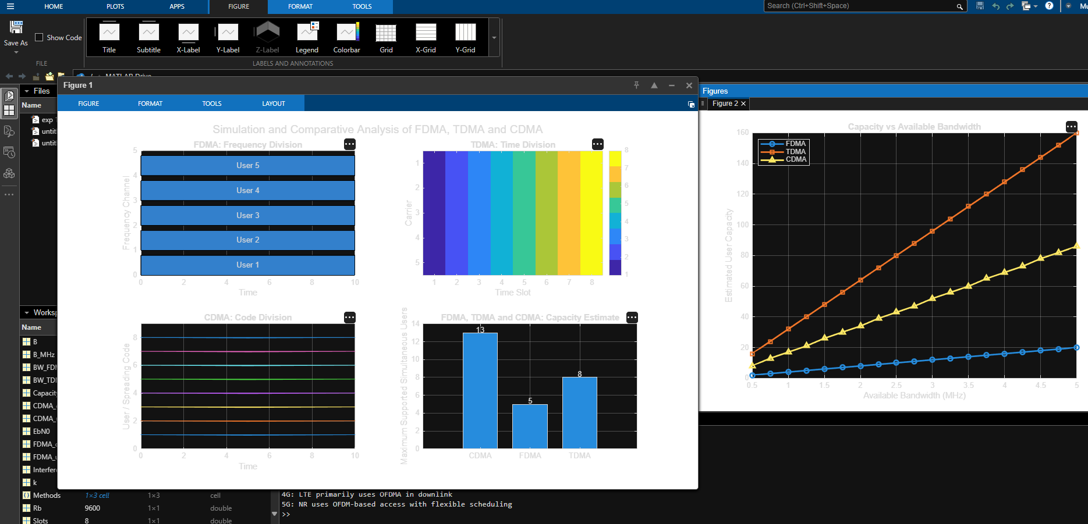

PROGRAM 2 : CDMA SIR analysis

clc;
clear;
close all;

% Simulation and Comparative Analysis of FDMA, TDMA and CDMA

%% 1. System Parameters
B = 1.25e6;
BW_FDMA = 250e3;
BW_TDMA = 250e3;
Slots = 8;
Rb = 9.6e3;
EbN0 = 5;
Interference = 0.2;

%% 2. User Capacity
CDMA_users = 13;
FDMA_users = 5;
TDMA_users = 8;

Methods = {'CDMA','FDMA','TDMA'};
Capacity = [CDMA_users FDMA_users TDMA_users];

fprintf('\nCDMA SIMULATION ANALYSIS\n');
fprintf('------------------------\n');
fprintf('CDMA Capacity = %d users\n',CDMA_users);
fprintf('FDMA Capacity = %d users\n',FDMA_users);
fprintf('TDMA Capacity = %d users\n',TDMA_users);

%% 3. CDMA Resource Allocation
figure('Color','w');

subplot(2,2,1);
hold on;
for k = 1:13
plot([0 10],[k k],'LineWidth',1.5);
end
hold off;
xlabel('Time');
ylabel('User / Spreading Code');
title('CDMA Resource Allocation');
ylim([0 14]);
xlim([0 10]);
grid on;

%% 4. Capacity Comparison
subplot(2,2,2);
bar(Capacity,0.7);
set(gca,'XTick',1:3,'XTickLabel',Methods);
ylabel('Maximum Supported Simultaneous Users');
title('FDMA, TDMA and CDMA: Capacity Estimate');
ylim([0 14]);
yticks(0:2:14);
grid on;

for k = 1:3
text(k,Capacity(k)+0.3,num2str(Capacity(k)), ...
'HorizontalAlignment','center');
end

%% 5. CDMA Capacity vs Bandwidth
B_MHz = 0.5:0.25:5;

CDMA_capacity = floor((B_MHz*1e6/Rb)./ ...
(EbN0*(1+Interference)));

subplot(2,2,3);
plot(B_MHz,CDMA_capacity,'-o','LineWidth',2);
xlabel('Available Bandwidth (MHz)');
ylabel('Estimated Number of Users');
title('CDMA Capacity vs Bandwidth');
grid on;

%% 6. CDMA Capacity vs Interference
I = 0:0.1:1;
CDMA_interference_capacity = floor((B/Rb)./ ...
(EbN0*(1+I)));

subplot(2,2,4);
plot(I,CDMA_interference_capacity,'-s','LineWidth',2);
xlabel('Interference Factor');
ylabel('Estimated Number of Users');
title('CDMA Capacity vs Interference');
grid on;

sgtitle('CDMA Simulation and Comparative Analysis');

%% 7. Mobile Generation Context
fprintf('\nMOBILE GENERATION CONTEXT\n');
fprintf('1G: Mainly analog FDMA\n');
fprintf('2G: IS-95 uses CDMA\n');
fprintf('3G: WCDMA and CDMA2000 use CDMA-based access\n');
fprintf('4G: LTE primarily uses OFDMA in downlink\n');
fprintf('5G: NR uses OFDM-based access with flexible scheduling\n');

%% 8. CDMA Analysis
fprintf('\nCDMA ANALYSIS\n');
fprintf('-------------\n');
fprintf('CDMA allows users to share time and frequency.\n');
fprintf('Each user is distinguished by a spreading code.\n');
fprintf('Increasing interference reduces estimated capacity.\n');
fprintf('CDMA capacity depends on bandwidth, data rate and Eb/N0.\n');

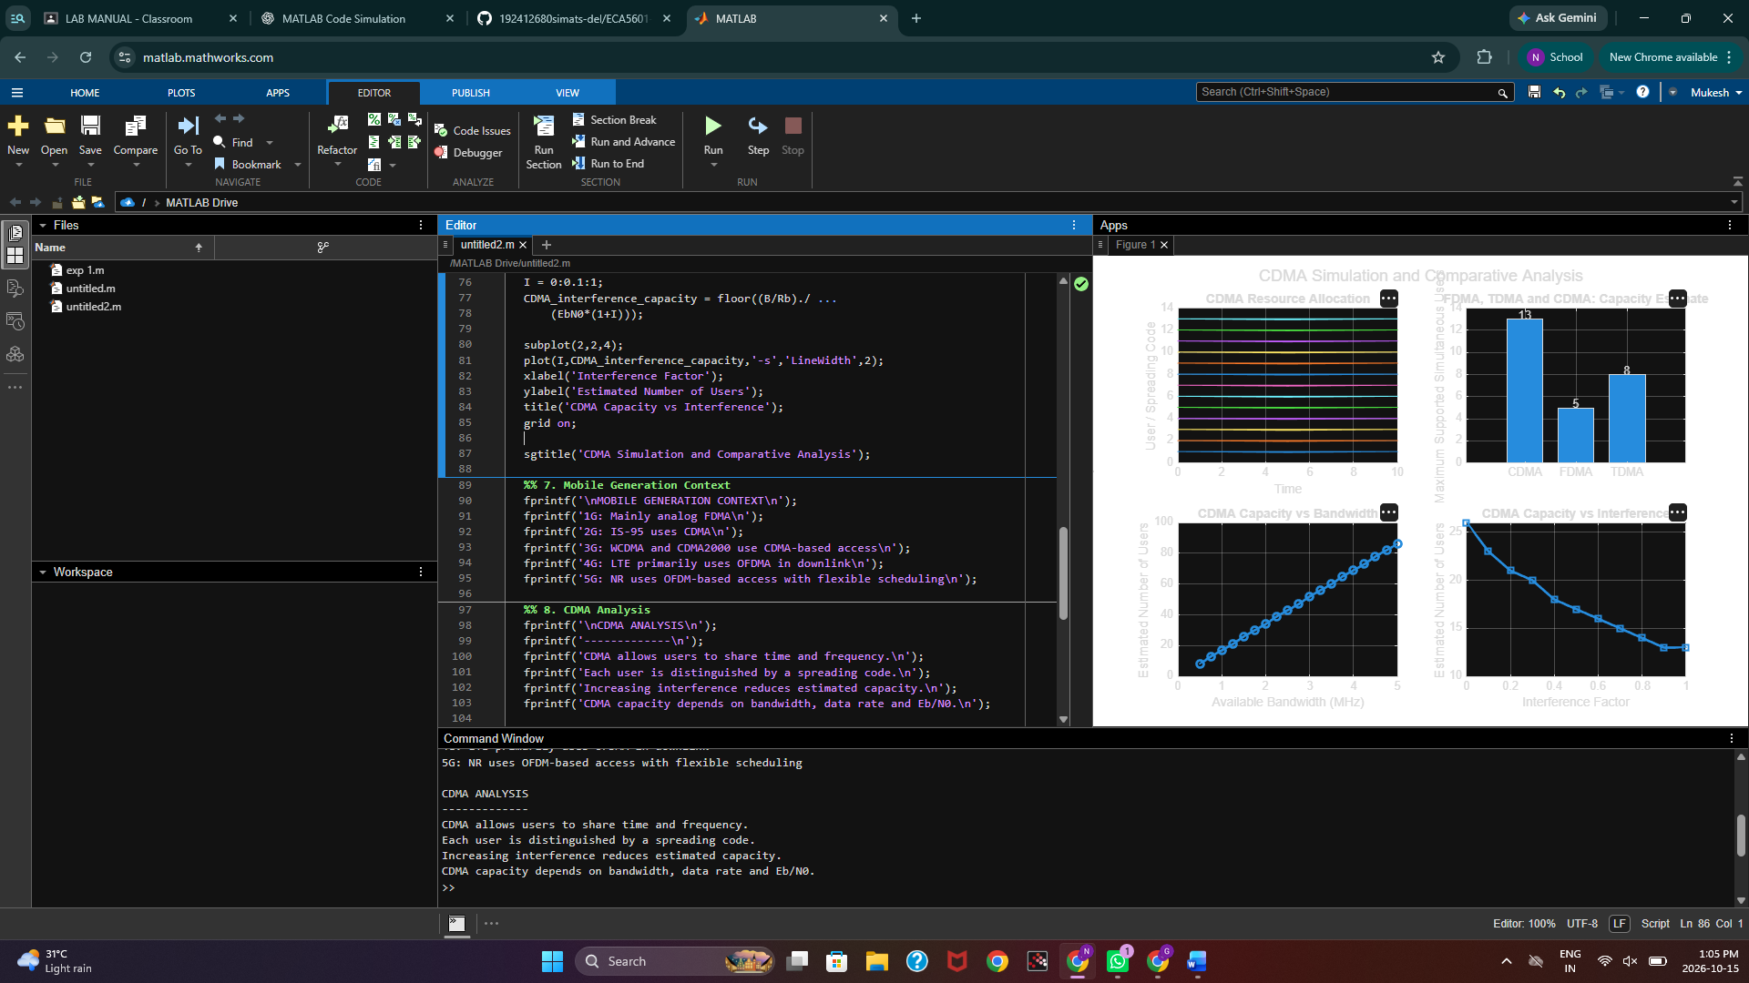

OBJECTIVE 3 : MOBILE GENERATION COMPARISON

clc;
clear;
close all;

% Mobile Generation Comparison: 1G to 5G

%% Mobile Generation Parameters
Generation = {'1G','2G','3G','4G','5G'};

% Representative peak data rates in Mbps (illustrative)
DataRate = [0.0024 0.064 2 100 1000];

% Representative latency in milliseconds (illustrative)
Latency = [500 300 100 20 1];

% Multiple access technologies (numeric coding for plotting)
% 1 = FDMA, 2 = TDMA, 3 = CDMA, 4 = OFDMA, 5 = OFDM-based NR
AccessCode = [1 2 3 4 5];

AccessNames = {'FDMA','TDMA/FDMA','CDMA','OFDMA','OFDM-based NR'};

%% Display Comparison
fprintf('\nMOBILE GENERATION COMPARISON\n');
fprintf('------------------------------------------------------\n');
fprintf('Generation\tData Rate (Mbps)\tLatency (ms)\tAccess\n');

for k = 1:5
fprintf('%s\t\t%.4f\t\t\t%d\t\t%s\n', ...
Generation{k},DataRate(k),Latency(k),AccessNames{k});
end

%% 1. Data Rate Comparison
figure('Color','w');
bar(DataRate);
set(gca,'XTick',1:5,'XTickLabel',Generation);
xlabel('Mobile Generation');
ylabel('Representative Data Rate (Mbps)');
title('1G to 5G Data Rate Comparison');
grid on;

%% 2. Latency Comparison
figure('Color','w');
bar(Latency);
set(gca,'XTick',1:5,'XTickLabel',Generation);
xlabel('Mobile Generation');
ylabel('Representative Latency (ms)');
title('1G to 5G Latency Comparison');
grid on;

%% 3. Multiple Access Technology Comparison
figure('Color','w');
bar(AccessCode);
set(gca,'XTick',1:5,'XTickLabel',Generation);
set(gca,'YTick',1:5);
set(gca,'YTickLabel',AccessNames);
xlabel('Mobile Generation');
ylabel('Multiple Access Technology');
title('Multiple Access Technologies from 1G to 5G');
grid on;

%% 4. Combined Comparison
figure('Color','w','Position',[100 100 1000 600]);

subplot(2,1,1);
semilogy(1:5,DataRate,'-o','LineWidth',2,'MarkerSize',8);
set(gca,'XTick',1:5,'XTickLabel',Generation);
xlabel('Mobile Generation');
ylabel('Data Rate (Mbps)');
title('Data Rate Evolution');
grid on;

subplot(2,1,2);
semilogy(1:5,Latency,'-s','LineWidth',2,'MarkerSize',8);
set(gca,'XTick',1:5,'XTickLabel',Generation);
xlabel('Mobile Generation');
ylabel('Latency (ms)');
title('Latency Evolution');
grid on;

%% 5. Generation Summary
fprintf('\nGENERATION SUMMARY\n');
fprintf('1G: Analog cellular communication, mainly FDMA\n');
fprintf('2G: Digital cellular systems; GSM uses TDMA/FDMA\n');
fprintf('3G: CDMA-based systems such as WCDMA and CDMA2000\n');
fprintf('4G: LTE uses OFDMA in downlink and SC-FDMA in uplink\n');
fprintf('5G: NR uses flexible OFDM-based waveforms and scheduling\n');

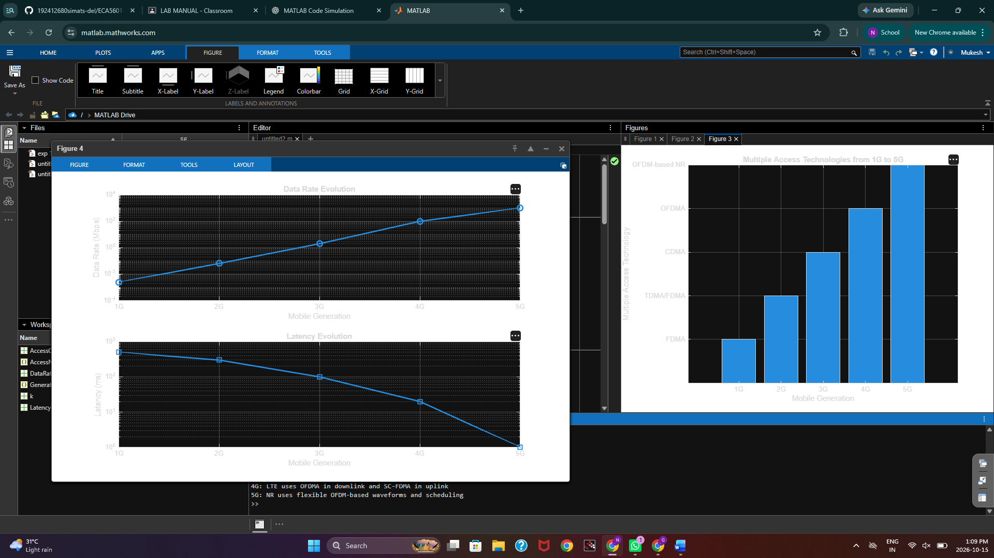

OBJECTIVE 4 RESOURCE ALLOCATION DIAGRAM

clc;
clear;
close all;

figure('Color','w','Position',[100 100 1100 700]);

%% 1. FDMA Resource Allocation
subplot(2,2,1);
hold on;

for k = 1:5
rectangle('Position',[0 k-1 10 0.8], ...
'FaceColor',[0.2 0.5 0.9], ...
'EdgeColor','k');
text(5,k-0.6,sprintf('User %d',k), ...
'HorizontalAlignment','center');
end

hold off;
xlim([0 10]);
ylim([0 5]);
xlabel('Time');
ylabel('Frequency Channels');
title('FDMA: Frequency Division');
grid on;

%% 2. TDMA Resource Allocation
subplot(2,2,2);
hold on;

colors = lines(4);

for k = 1:4
for s = 1:4
rectangle('Position',[s-1 k-1 0.9 0.8], ...
'FaceColor',colors(k,:), ...
'EdgeColor','k');
text(s-0.55,k-0.6,sprintf('U%d',k), ...
'HorizontalAlignment','center');
end
end

hold off;
xlim([0 4]);
ylim([0 4]);
xlabel('Time Slots');
ylabel('Carrier');
title('TDMA: Time Division');
xticks(1:4);
yticks(1:4);
grid on;

%% 3. CDMA Resource Allocation
subplot(2,2,3);
hold on;

colors = lines(6);

for k = 1:6
rectangle('Position',[0 0 10 6], ...
'FaceColor','none','EdgeColor','k');
plot([0 10],[k-0.5 k-0.5], ...
'Color',colors(k,:),'LineWidth',2);
text(5,k-0.5,sprintf('User %d - Code %d',k,k), ...
'HorizontalAlignment','center', ...
'BackgroundColor','w');
end

hold off;
xlim([0 10]);
ylim([0 6]);
xlabel('Time');
ylabel('Spreading Codes');
title('CDMA: Code Division');
grid on;

%% 4. Mobile Generation Resource Allocation
subplot(2,2,4);
hold on;

genNames = {'1G','2G','3G','4G','5G'};
accessNames = {'FDMA','TDMA/FDMA','CDMA','OFDMA','OFDM-based NR'};

for k = 1:5
rectangle('Position',[0 k-1 10 0.8], ...
'FaceColor',colors(mod(k-1,size(colors,1))+1,:), ...
'EdgeColor','k');
text(5,k-0.6,[genNames{k} ' - ' accessNames{k}], ...
'HorizontalAlignment','center');
end

hold off;
xlim([0 10]);
ylim([0 5]);
xlabel('Illustrative Resource Allocation');
ylabel('Mobile Generation');
title('Mobile Generations and Access Methods');
yticks(0.4:1:4.4);
yticklabels({'5G','4G','3G','2G','1G'});
grid on;

sgtitle('Resource Allocation Diagrams: FDMA, TDMA, CDMA and 1G-5G');

